Technical Modification Statement

Project Name: Uniters Policy Insurance

Issue Title: Data Transmission to Uniters Group

Date: October 28, 2021

Prepared By
Document Owner(s) | Project/Organization Role
Michael Barber | Software Developer

Modification Version Control
Issue. Version | Date | Author | Change Description
M01.00 | 10/28/21 | Michael Barber | Created document.

Table of Contents
Prepared By 2
Modification Version Control 2
Requirements Description 5

Uniter Document for XML Format 6

Brains Policty API 23

Policy Create 27

Policy Delivered 43

Policy Status 49

Process Summary Flow 57

Main Process 57

Process Detail for Created, Update and Delivered 58

Overview SQL Server Tables and Stored Procedures 61

Assumption and Concerns 62

Filetable Definations 63

Requirements Description
Uniters Group would like to offer the ability for our customers to purchase insurance. They will be available for purchase at the time of sale.
The cost of the policy is broken down into three groups and multiple tiers with each.
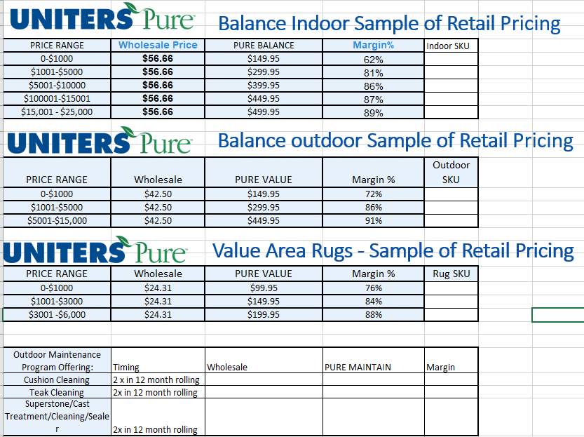
- It has yet to be determined if the SKU or service charge will be used to charge the customer.
Below is the Uniter Document for the XML Format.

Uniters Group

Sales data / Warranty import

Summary

- File format
- Definition and specification of the fields
- XML File format definition
- XML File format example
- Option for when there is limited or no item information available
- Data transmission to Uniters Group
- Technical contacts

______________________________________________________________
- File Format
Uniters Group recommends and encourages the use of an XML file format.
This format has advantages over XLS or delimited file formats like CSV or TXT.
We’re available to evaluate alternative ways to integrate your IT system with Uniters North America’s CRM.

- Definition and specification of the fields

Header information and minimum set of data per policy

Element | Data | Required | Notes
policy | status | Yes | Options are NEW or UPDATE. Update represents any change in the previously communicated data
policy | reference | Yes | Unique policy reference (store unique sales receipt or invoice number)
policy | reference2 |  | Optional fields for other store references
policy | reference3 |  | Optional fields for other store references
policy | datetransmitted | No | Required date format is YYYY-MM-DD (e.g. 2009-11-25)
policy | dateordered | Yes | Required date format is YYYY-MM-DD (e.g. 2009-11-25)
policy | datedelivered | Yes | Required date format is YYYY-MM-DD (e.g. 2009-11-25)
policy | datecancelled |  | Must be specified if all policy items are cancelled
policy | premiumpaid  currency |  | ISO 4217 currency code
policy | premiumpaid | Yes | Premium paid for the warranty (numeric only, e.g. 99.99)
policy | warrantycostpricecurrency |  | ISO 4217 currency code
policy | warrantycostprice | Yes | Price paid to Uniters for the warranty (numeric only, e.g. 99.99)
policy | salesman |  | Name or code of the salesman
policy | storecode | Yes | Store code must be specified so that we can look up the correct retailer record in our database. Store code list will be provided by Customer
policy | retailerbrand | Yes / No | This indicates the warranty type. A Uniters part number must be specified. Only one retailer brand can be specified for each <policy> record. Can be left out if the <retailerbrandband> field is set at the item level.
policy | kit |  | Yes or No. Indicates whether a kit was supplied with this warranty. Defaults to no if not specified
policy | requestkit |  | Yes or No. Indicates whether Uniters needs to ship a kit to the consumer. Defaults to no if not specified.
policy | consumer | Yes
consumer | reference | No | An optional unique reference to the consumer
consumer | title |  | Title can be one of Mr, Mrs, Miss, Ms or Dr. Can be skipped or left blank if not known. If set to anything else it will be ignored
consumer | firstname | Yes
consumer | lastname | Yes
consumer | address | At least one | At least one address must be specified, this will be the consumer’s home address. If there are other addresses then these can be specified as well
consumer | contact | At least one
policy | policyItem | At least one

Element specifications

Element | Field | Required | Notes
address | type |  | Address type can be one of HOME_ADDRESS or INVOICE_ADDRESS
address | line1 | Yes
address | line2
address | city | Yes
address | state | Yes
address | ZIP | Yes
address | country |  | If blank it defaults to USA
contact | type |  | Contact type can be one of PHONE, HOME_PHONE, MOBILE_PHONE, WORK_PHONE, EMAIL or FAX.
contact | detail | Yes | The actual contact data
contact | extension |  | Optional phone extension number (this applies to phone related contact types only)
policyitem | status |  | Options are NEW, CANCEL or REPLACEMENT.  CANCEL represents a return of the item due to consumer return. If consumer reselect a different item we need to receive an NEW record for the new item too.  REPLACEMENT must be used only when an item has been replaced due to a claim submitted by the consumer and the reselection process in the store has been completed.
policyitem | retailerbrandband |  | Optional warranty type for the item
policyitem | manufacturer |  | This can be either a free-text field or a name from a predefined list of manufacturers which must be provided in advance to UNA for proper look up in our database
policyitem | itemtype | Yes | At least one must be specified. A predetermined list of item type will be provided (chair, two seats sofa, ottoman, etc).
policyitem | modeldescription | Yes
policyitem | modelname | Yes | Manufacturer furniture model name
policyitem | modelnumber |  | Manufacturer or retailer furniture part number or SKU
policyitem | characteristics |  | Additional characteristics
policyitem | color |  | Colour of the leather/wood/textile
policyitem | serialnumber
policyitem | material | Yes | Choice of values that Indicates the material that covers the majority of the item surface. Typically one of: LEATHER, FABRIC, WOOD, GLASS etc
policyitem | seats | Yes / No | Number of seats for this item. Not required if item type is provided.
policyitem | retailvalue  currency |  | ISO 4217 currency code
policyitem | retailvalue | Yes | The price paid by the consumer for the item
policyitem | numberofitems |  | Indicates the quantity of identical items sold. Defaults to 1 if not specified
policyitem | purchasedate |  | Purchase date of the item.  Required date format is YYYY-MM-DD (e.g. 2009-11-25)
policyitem | dealertaxrate  currency |  | ISO 4217 currency code
policyitem | dealertaxrate |  | Dealer tax rate of the item.  (numeric only, e.g. 99.99)
policyitem | quality
policyitem | replacementcost  currency |  | ISO 4217 currency code
policyitem | replacementcost |  | Replacement cost of the item.  (numeric only, e.g. 99.99)

- XML file format definition

Policy data to be provided in an XML format file. One <policy> element per policy. Policy = Sales receipt or invoice.

<?xml version="1.0" encoding="UTF-8"?>
<policies>
<policy>
<status></status>
<reference></reference>
<reference2></reference2>
<reference3></reference3>
<datetransmitted></datetransmitted>
<dateordered></dateordered>
<datedelivered></datedelivered>
<datecancelled></datecancelled>
<premiumpaidcurrency></premiumpaidcurrency>
<premiumpaid></premiumpaid>
<warrantycostpricecurrency></warrantycostpricecurrency>
<warrantycostprice></warrantycostprice>
<salesman></salesman>
<storecode></storecode>
<retailerbrand></retailerbrand>
<kit></kit>
<requestkit></requestkit>
<consumer>
<reference></reference>
<title></title>
<firstname></firstname>
<lastname></lastname>
<addresses>
<address>
<type></type>
<line1></line1>
<line2></line2>
<city></city>
<state></state>
<ZIP></ZIP>
<country></country>
</address>
</addresses>
<contacts>
<contact>
<type></type>
<detail></detail>
<extension></extension>
</contact>
</contacts>
</consumer>
<policyitems>
<policyitem>
<status></status>
<retailerbrandband></retailerbrandband>
<manufacturer></manufacturer>
<itemtype></itemtype>
<modeldescription></modeldescription>
<modelname></modelname>
<modelnumber></modelnumber>
<characteristics></characteristics>
<color></color>
<serialnumber></serialnumber>
<material></material>
<seats></seats>
<retailvaluecurrency></retailvaluecurrency>
<retailvalue></retailvalue>
<numberofitems></numberofitems>
<purchasedate></purchasedate>
<dealertaxratecurrency></dealertaxratecurrency>
<dealertaxrate></dealertaxrate>
<quality></quality>
<replacementcostcurrency></replacementcostcurrency>
<replacementcost></replacementcost>
</policyitem>
</policyitems>
</policy>
</policies>

IMPORTANT NOTES:

- A single file transmission is delimited by <policies></policies>
- Each policy record is delimited by <policy></policy>
- The elements must appear in the file in the order given.
- Updates on pre-transmitted policies are only allowed for new, cancelled and replaced policy items, not for any other data on the policy.
- If a single sales receipt contains more than one warranty part number on it, there must be a policy record for each warranty.
- An exception to the above is if the warranty part numbers are specified at the item level (in <retailerbrandband>). In this case all the items from a sales receipt can be sent in the same policy record.
- If multiple items are included in different sales receipts for the same warranty then these can be sent as different <policy> records, however they must all have the same policy reference, store number, and retailerbrand so they can be linked together in our system.
- All text fields are unlimited in size but we will only use the first 255 characters of each.
- If any text field contains any of the XML reserved characters [& (ampersand),< (less than),> (greater than),’ (single quote),” (double quote)] then it MUST be enclosed in a CDATA section i.e. <![CDATA[ … text… ]]>.
- A policy is considered completely cancelled when all the policy items are cancelled. In this case a cancellation date must be provided.
- The date transmitted field is the date the record was sent to us.

- XML file format example

James Simpson bought a new Loveseat and a Corner element from a local store in West Palm Beach, FL.
This is how the record should be formatted.

<?xml version="1.0" encoding="UTF-8"?>
<policies>
<policy>
<status>NEW</status>
<reference>12345-2009</reference>
<reference2>XYZ987</reference2>
<reference3></reference3>
<datetransmitted>2021-01-05</datetransmitted>
<dateordered>2021-01-01</dateordered>
<datedelivered>2021-01-04</datedelivered>
<premiumpaid>129.99</premiumpaid>
<salesman>Sue Jones</salesman>
<storecode>TL1</storecode>
<retailerbrand>VRS3451</retailerbrand>
<kit>Yes</kit>
<requestkit>No</requestkit>
<consumer>
<reference>JS001</reference>
<title>Mr</title>
<firstname>James</firstname>
<lastname>Simpson</lastname>
<addresses>
<address>
<type>HOME_ADDRESS</type>
<line1>742 Evergreen Terrace</line1>
<line2></line2>
<city>West Palm Beach</city>
<state>FL</state>
<ZIP>33401</ZIP>
<country>USA</country>
</address>
<address>
<type>INVOICE_ADDRESS</type>
<line1>650 Western Way</line1>
<line2></line2>
<city>West Palm Beach </city>
<state>FL</state>
<ZIP>33401</ZIP>
<country>USA</country>
</address>
</addresses>
<contacts>
<contact>
<type>HOME_PHONE</type>
<detail>5615556832</detail>
<extension></extension>
</contact>
<contact>
<type>EMAIL</type>
<detail>jamess1234@gmail.com</detail>
</contact>
</contacts>
</consumer>
<policyitems>
<policyitem>
<status>NEW</status>
<manufacturer><![CDATA[FLANDERS & SONS FURNITURE]]></manufacturer>
<itemtype>TWO_SEAT_SOFA</itemtype>
<modelname>Modern Loveseat 2009</modelname>
<modelnumber>123435VV</modelnumber>
<characteristics>Aniline Leather</characteristics>
<color>Black</color>
<serialnumber>1234567890000</serialnumber>
<material>LEATHER</material>
<numberofitems>2</numberofitems>
<retailvalue>499.99</retailvalue>
</policyitem>
<policyitem>
<status>NEW</status>
<manufacturer>NC FURNITURE</manufacturer>
<modeldescription>Corner Small</modeldescription>
<modelname>Just a basic corner</modelname>
<characteristics>Pigmented Leather</characteristics>
<color>Blue</color>
<material>LEATHER</material>
<seats>1</seats>
<retailvalue>299</retailvalue>
</policyitem>
</policyitems>
</policy>
</policies>

PLEASE NOTE:
- Content of the fields in CAPITAL letters represent an option from a pre-defined list and are not free text. It’s not a problem if you’re unable to map your internal values to our pre-defined list.
- As shown in this example any optional (i.e. non-mandatory) elements can be left out of the file if desired.

- Option for when there is limited or no item information available

There are some cases where information on individual items is not available. In these cases a single “dummy” item must be provided with whatever information is available (if any).
For example if a consumer has purchased 3 items with a total value of $1234 the XML for the item would be:

<policyitems>
<policyitem>
<status>NEW</status>
<modeldescription>3 items</modeldescription>
<retailvalue>1234.00</retailvalue>
</policyitem>
</policyitems>

If there is no information for the description field then this can be left out.
If there is no information at all then please provide a policyitem section like this:

<policyitems>
<policyitem>
<status>NEW</status>
</policyitem>
</policyitems>
- Data transmission to Uniters Group

Data should be made available for Uniters preferably on a daily basis. Weekly download is also accepted. We support FTP, SFTP, SSL FTP. We have an FTP site available for your convenience if you prefer to use ours. Please let us know about your preferences.
To allow for easy identification of the files sent we would like the creation date to be appended to the filename in the format “_yyyymmdd”, e.g. “UnitersData_20170531”.
If on any particular day there is no policy data we still require a file to be sent, in this case it should just contain the headers:

<?xml version="1.0" encoding="UTF-8"?>
<policies>
</policies>
- Technical contacts

We are available regarding any further information and/or to provide you with assistance. For any technical questions, please refer to Uniters Development team at dev@unitersgroup.com.
We look forward to working with you.
Uniters Development Team

Brains Policy API

Overview - Uniters API (Brains Policy API)
Pre-processing build and configuration of audit and control tables.
- API parameter table
- API processing audit table
During the execution of each API the sent XML will be recorded into a SQL table and this will be used to will track and audit run-time parameters such as the last processed date. This is similar to how we currently track API on other applications.
Notification will be sent to DatabaseAdmins@SummerClassics.com via email with any unsuccessful API response
The list of the API call is listed below.
The below is sourced from here:
https://sites.google.com/a/unitersgroup.com/brains-policy-api/home

Brains Overview
A web service is provided which allows remote systems to create a policy in Brains.
Access to the web service is only available using HTTPS and it requires authentication.
The web service is REST style using JSON or XML as the data format.

Web service details
The web service base URL for testing is https://testportal.palladio.biz/service/v1/policies/
The base URL for the production system will be provided separately when required.
See each individual web service for details of the rest of the URL.
- POLICY_CREATE
- POLICY_DELIVERED
- POLICY_STATUS_CHECK
Authentication
All the above web services are secured and require a username/password to access them.
Credentials for the production and test systems will be provided on request.
These must be sent using HTTP Basic authentication with every request.

Language
A number of the text fields from the web services can be returned in different languages.
The default language is English, to request a different language an Accept-language header must be provided.

Terminology
Plan/policy – a single unit of coverage containing one or more items
Policy item – an individual item that is covered by a plan

API changes
All changes to the API will be recorded on the change log page.

CHANGE LOG
Date | Page | Description of change
2015-11-02 | CHANGE LOG | Add this page
2016-03-01 | POLICY_CREATE | Allow data to be specified in XML as well as JSON
2016-06-28 | POLICY_CREATE | Add field requestkit
2016-07-19 | POLICY_CREATE | Remove host name from example URL’s, these will be provided on request for test and production systems
2017-02-01 | POLICY_CREATE | Add per-customer access token to API to provide added security
2017-07-25 | POLICY_CREATE | Remove policy item cost field, use replacementCost field instead
2017-07-25 | POLICY_CREATE | Add premiumPaid and warrantyCostPrice at the policy item level
2017-09-06 | POLICY_CREATE | Added default values for seats (0) and numberofitems (1)
2017-09-11 | POLICY_CREATE | Allow delivery date to be optional
2017-09-11 | POLICY_CREATE | Added note about maximum text field length (255)
2017-09-11 | POLICY_CREATE | Added error code 3021 for duplicate policy item
2018-04-13 | POLICY_CREATE | Added note about treatment of premium paid and warranty cost price at policy and item level
2019-05-09 | POLICY_CREATE | Added fields shipDate and shipQuantity
2021-01-12 | POLICY_CREATE | Return unique id for policy
2021-01-12 | POLICY_DELIVERED | New end point to set delivery date for an existing policy
2021-07-01 | POLICY_STATUS_CHECK | New end point to get the status of an existing policy

POLICY_CREATE
Description

REST style web service to add a new policy.
Payload is in JSON or XML format and represents a single policy.
If on a single sales check there is more than one coverage type then each type must be sent as a separate record, each one including only the covered items.
A single policy can be sent using multiple records, e.g. if there are items that are delivered on different days, the policy reference and plan type are used to find the correct policy.
The delivery date is optional, if specified the following conditions apply:
* All new items within the same record should have the same delivery dates.
* All cancellations must be within 30 days of the original delivery date.
If not specified then a default delivery date of purchase date + offset will apply (the offset is customer specific)
If a consumer has multiple plans, for them to be linked in our system they must use the same consumer reference.
Refer to the XML importer document for details of the individual fields.
All text fields are limited to 255 characters, any text beyond this limit will be discarded.

Detail

URL | .../service/v1/policies
Protocol | HTTPS
Method | POST
Query string | N/A
Return | 200 OK + JSON data
 | 400 Bad request (e.g. if a parameter is missing)
 | 401 Unauthorised (e.g. wrong credentials supplied)
 | 406 Not acceptable (client must accept JSON)
 | 415 Unsupported media type (must be JSON or XML)
Example

Request URL
POST https://HOSTNAME/service/v1/policies

Request body (JSON)
{
"accessToken": "XXXX",
"status": "XXXX",
"reference": "XXXX",
"reference2": "XXXX",
"reference3": "XXXX",
"premiumpaidcurrency": "XXX",
"premiumpaid": NNNN.NN,
"warrantycostpricecurrency": "XXX",
"warrantycostprice": NNNN.NN,
"salesman": "XXXX",
"storecode": "XXXX",
"retailerbrand": "XXXX",
"kit": true,
"requestkit": true,
"kitShipped": true,
"kitName": "XXXX",
"kitCode ": "XXXX",
"trackingNumber": "XXXX",
"shipDate": "YYYY-MM-DD",
"shipQuantity": NNNN,
"consumer": {
"reference": "XXXX",
"title": "XXXX",
"firstname": "XXXX",
"lastname": "XXXX",
"addresses": [
{
"type": "XXXX",
"line1": "XXXX",
"line2": "XXXX",
"city": "XXXX",
"state": "XXXX",
"zip": "XXXX",
"country": "XXXX"
}
],
"contacts": [
{
"type": "XXXX",
"detail": "XXXX",
"extension": "XXXX"
},
{
"type": "XXXX",
"detail": "XXXX",
"extension": "XXXX"
},
....
]
},
"policyitems": [
{
"status": "XXXX",
"dateordered": "YYYY-MM-DD",
"datedelivered": "YYYY-MM-DD",
"datecancelled": "YYYY-MM-DD",
"manufacturer": "XXXX",
"itemtype": "XXXX",
"modeldescription": "XXXX",
"modelname": "XXXX",
"modelnumber": "XXXX",
"characteristics": "XXXX",
"color": "XXXX",
"serialnumber": "XXXX",
"material": "XXXX",
"seats": NNNN,
"premiumpaidcurrency": "XXX",
"premiumpaid": NNNN.NN,
"warrantycostpricecurrency": "XXX",
"warrantycostprice": NNNN.NN,
"retailvaluecurrency": "XXX",
"retailvalue": NNNN.NN,
"dealertaxratecurrency": "XXX",
"dealertaxrate": NNNN.NN,
"replacementcostcurrency": "XXX",
"replacementcost": NNNN.NN,
"numberofitems": NNNN
},
....
]
}

Request body (XML)
<policy>
<accessToken>XXXX</accessToken>
<status>NEW</status>
<reference>XXXX</reference>
<reference2>XXXX</reference2>
<reference3>XXXX</reference3>
<premiumpaidcurrency>XXX</premiumpaidcurrency>
<premiumpaid>NNN.NN</premiumpaid>
<warrantycostpricecurrency>XXX</warrantycostpricecurrency>
<warrantycostprice>NNN.NN</warrantycostprice>
<salesman>XXXX</salesman>
<storecode>XXXX</storecode>
<retailerbrand>XXXX</retailerbrand>
<kit>true</kit>
<requestkit>true</requestkit>
<kitShipped>true</kitShipped>
<kitName>XXXX</kitName>
<kitCode >XXXX</kitCode >
<trackingNumber>XXXX</trackingNumber>
<consumer>
<reference>XXXX</reference>
<title>XXXX</title>
<firstname>XXXX</firstname>
<lastname>XXXX</lastname>
<addresses>
<address>
<type>HOME_ADDRESS</type>
<line1>XXXX</line1>
<line2>XXXX</line2>
<city>XXXX</city>
<state>XXXX</state>
<zip>XXXX</zip>
<country>XXXX</country>
</address>
</addresses>
<contacts>
<contact>
<type>HOME_PHONE</type>
<detail>1234567890</detail>
<extension>2468</extension>
</contact>
<contact>
<type>EMAIL</type>
<detail>me@here.com</detail>
</contact>
</contacts>
</consumer>
<policyitems>
<policyitem>
<status>NEW</status>
<dateordered>YYYY-MM-DD</dateordered>
<datedelivered>YYYY-MM-DD</datedelivered>
<manufacturer>XXXX</manufacturer>
<itemtype>XXXX</itemtype>
<modeldescription>XXXX</modeldescription>
<modelname>XXXX</modelname>
<modelnumber>XXXX</modelnumber>
<characteristics>XXXX</characteristics>
<color>XXXX</color>
<serialnumber>XXXX</serialnumber>
<material>XXXX</material>
<seats>NNNN</seats>
<premiumpaidcurrency>XXX</premiumpaidcurrency>
<premiumpaid>NNN.NN</premiumpaid>
<warrantycostpricecurrency>XXX</warrantycostpricecurrency>
<warrantycostprice>NNN.NN</warrantycostprice>
<retailvaluecurrency>XXX</retailvaluecurrency>
<retailvalue>NNNN.NN</retailvalue>
<dealertaxratecurrency>XXX</dealertaxratecurrency>
<dealertaxrate>NNNN.NN</dealertaxrate>
<replacementcostcurrency>XXX</replacementcostcurrency>
<replacementcost>NNNN.NN</replacementcost>
<numberofitems>NNNN</numberofitems>
</policyitem>
</policyitems>
</policy>

Notes
- If seats is not specified it defaults to 0
- If numberofitems is not specified it defaults to 1
- Premium paid and warranty cost price can be specified at the policy or item level. If used at the policy level it should be the total for all the items purchased, if at the item level then it should be only the amount for that item. If both are specified then the policy level one will be used.

Response header (success)
Server: Apache-Coyote/1.1
Content-Type: application/json;charset=UTF-8
Transfer-Encoding: chunked
Date: Tue, 05 Sep 2014 15:16:17 GMT

200 OK

Response body
{
"id": NNNN
}

Response header (error)
Server: Apache-Coyote/1.1
Content-Type: application/json;charset=UTF-8
Transfer-Encoding: chunked
Date: Tue, 05 Sep 2014 15:16:17 GMT

400 Bad Request

Response body
{
"code": NNNN,
"message": "XXXX"
}

Data scenarios

Normal operations to test
- New plan with one item
- New plan with multiple items with same purchase date
- New plan with multiple items with different purchase date
- Update plan with one new item with same purchase date as the original
- Update plan with one new item with different purchase date from the original
- Update plan with multiple new items with same purchase date as the original
- Update plan with multiple new items with different purchase date from the original
- Cancel plan with one cancelled item (Original plan had one item)
- Cancel plan with one cancelled item (Original plan had multiple items)
- Cancel plan with multiple cancelled items (Not all items cancelled)
- Cancel plan with multiple cancelled items (All items cancelled)
- New plan for existing consumer

Normal Test | Policy status | Item status | Return
1 | NEW | NEW | 200
2 | NEW | NEW | 200
3 | NEW | NEW | 200
4 | UPDATE | NEW | 200
5 | UPDATE | NEW | 200
6 | UPDATE | NEW | 200
7 | UPDATE | NEW | 200
8 | CANCEL | CANCEL | 200
9 | CANCEL | CANCEL | 200
10 | CANCEL | CANCEL | 200
11 | CANCEL | CANCEL | 200
12 | NEW | NEW | 200

Abnormal operations to test - these will all return an error
- New plan with multiple items with different delivery dates
- Update plan with one cancelled item, cancellation date 31 days after delivery date
- Cancel plan, cancellation date 31 days after earliest delivery date
- New plan with missing data (see error codes below)

Abnormal Test | Policy status | Item status | Return
1 | NEW | NEW | 400 + Error code
2 | UPDATE | CANCEL | 400 + Error code 3006
3 | CANCEL | CANCEL | 400 + Error code 3005
4 | NEW | NEW | 400 + Error code

Error codes

Code | Message | Note
1001 | No data
1003 | Invalid access token

Code | Message | Note
2001 | No policy status
2002 | No policy reference
2003 | No premium paid | Can be either at the policy or item level
2004 | No store code
2005 | No brand code
2006 | No consumer
2007 | No consumer lastname
2008 | No consumer address
2009 | No consumer address line1
2010 | No consumer address city
2011 | No consumer address state
2012 | No consumer address ZIP
2013 | No consumer contact | Either no contacts or a blank contact
2014 | No items
2015 | No item status
2016 | No item order date
2017 | No item delivery date | NOT USED, delivery date is optional
2018 | No item cancelled date
2019 | No item model description / item type | At least one of these fields must be specified
2020 | No item model name
2021 | No item retail value
2022 | No item warranty cost currency

Code | Message | Note
3001 | Order date before business start date
3002 | Delivery date before order date
3003 | Invalid store code | Code is real but store not active on order date
3004 | Invalid brand code | Code is real but brand not active for store on order date
3005 | Cannot cancel policy - too late | Must be within 30 days of earliest delivery date
3006 | Cannot cancel item - too late | NOT USED, 3005 WILL BE RETURNED
3007 | Cannot cancel policy - has claim | Policy cannot be cancelled if it has a claim
3008 | Cannot cancel item - has claim | NOT USED, 3007 WILL BE RETURNED
3009 | Item order date invalid | Date must be in format "yyyy-mm-dd"
3010 | Item delivery date invalid | Date must be in format "yyyy-mm-dd"
3011 | Item cancelled date invalid | Date must be in format "yyyy-mm-dd"
3012 | Item order date in the future | Date cannot be > today
3013 | Policy status invalid | Must be NEW, UPDATE or CANCEL
3014 | Item status invalid | Must be NEW or CANCEL
3015 | Cannot update policy - no policy
3016 | Cannot cancel policy - no policy
3017 | Cannot cancel item - no item
3018 | Invalid address type | Must be HOME_ADDRESS or INVOICE_ADDRESS
3019 | Invalid contact type | Must be PHONE, HOME_PHONE, MOBILE_PHONE,  WORK_PHONE or EMAIL
3020 | Duplicate policy | Policy status is NEW but policy already exists
3021 | Duplicate policy item | Policy and item status are new, item with reference2 already exists

Comments
You do not have permission to add comments.

POLICY_DELIVERED
Description

REST style web service to add delivery information for a policy.
Payload is in JSON or XML format and represents information for a single policy.
Updates the given policy with the given delivery date, will activate the policy if the delivery date is in the past, otherwise it will be activated on the delivery date.
Will return an error if the policy is already active.
There are two versions of this call, if the policy id is known then option 2 should be used, in this case the only parameter required is "datedelivered"
Refer to the XML importer document for details of the individual fields.
All text fields are limited to 255 characters, any text beyond this limit will be discarded.

Detail

URL | .../service/v1/policies/delivered  .../service/v1/policies/{id}/delivered
Protocol | HTTPS
Method | PUT
Query string | N/A
Return | 200 OK + JSON data
 | 400 Bad request (e.g. if a parameter is missing)
 | 401 Unauthorised (e.g. wrong credentials supplied)
 | 406 Not acceptable (client must accept JSON)
 | 415 Unsupported media type (must be JSON or XML)
Example

Request URL
1) PUT https://HOSTNAME/service/v1/policies/delivered
OR
2) PUT https://HOSTNAME/service/v1/policies/{id}/delivered

Request body (JSON)
{
"accessToken": "XXXX",
"reference": "XXXX",
"storecode": "XXXX",
"retailerbrand": "XXXX",
"dateordered": "YYYY-MM-DD",
"datedelivered": "YYYY-MM-DD"
}

Request body (XML)
<policy>
<accessToken>XXXX</accessToken>
<reference>XXXX</reference>
<storecode>XXXX</storecode>
<retailerbrand>XXXX</retailerbrand>
<dateordered>YYYY-MM-DD</dateordered>
<datedelivered>YYYY-MM-DD</datedelivered>
</policy>

Notes
- If a policy has multiple items with different order dates, the earliest should be used, the same applies to the delivery date

Response header (success)
Server: Apache-Coyote/1.1
Content-Type: application/json;charset=UTF-8
Transfer-Encoding: chunked
Date: Mon, 11 Jan 2021 15:16:17 GMT

200 OK

Response body
{}

Response header (error)
Server: Apache-Coyote/1.1
Content-Type: application/json;charset=UTF-8
Transfer-Encoding: chunked
Date: Tue, 11 Jan 2021 15:16:17 GMT

400 Bad Request

Response body
{
"code": NNNN,
"message": "XXXX"
}

Error codes

Code | Message | Note
1001 | No data
1003 | Invalid access token

Code | Message | Note
2002 | No policy reference
2004 | No store code
2005 | No brand code
2023 | No delivery date

Code | Message | Note
3002 | Delivery date before order date
3003 | Invalid store code | Code is real but store not active on order date
3004 | Invalid brand code | Code is real but brand not active for store on order date
3015 | Cannot update policy - no policy
3022 | Order date invalid | Date must be in format "yyyy-mm-dd"
3023 | Delivery date invalid | Date must be in format "yyyy-mm-dd"
3024 | Policy already active | Cannot set the delivery date for a policy which is already active

Comments
You do not have permission to add comments.

POLICY_STATUS_CHECK
Description

REST style web service to get the status of a policy.
If a matching policy is found then various status information is returned about it.
There are two versions of this call, if the policy id is known then option 2 should be used, in this case the only parameter required is "accessToken".
Refer to the XML importer document for details of the individual fields.

Detail

URL | .../service/v1/policies/status  .../service/v1/policies/{id}/status
Protocol | HTTPS
Method | GET
Query string | accessToken (required)
 | reference (required, not required for option 2)
 | storecode (optional, not required for option 2)
 | retailerbrand (optional, not required for option 2)
 | dateordered (optional, not required for option 2)
Return | 200 OK + JSON data
 | 400 Bad request (e.g. if a parameter is missing)
 | 401 Unauthorised (e.g. wrong credentials supplied)
 | 406 Not acceptable (client must accept JSON)
 | 415 Unsupported media type (must be JSON or XML)
Example

Request URL
1) GET https://HOSTNAME/service/v1/policies/status?accessToken=XXXX&reference=XXXX&storecode=XXXX&retailerbrand=XXXX&dateordered=YYYY-MM-DD
OR
2) GET https://HOSTNAME/service/v1/policies/{id}/status

Response header (success)
Server: Apache-Coyote/1.1
Content-Type: application/json;charset=UTF-8
Transfer-Encoding: chunked
Date: Thu, 01 Jul 2021 15:16:17 GMT

200 OK

Response body
[
{
"id": NNNN,
"reference": "XXXX",
"reference2": "XXXX",
"status": "XXXX",
"datecreated": "YYYY-MM-DDTHH:MM:SSZ",
"datedelivered": "YYYY-MM-DD",
"policyitems": [
{
"id": NNNN,
"reference": "XXXX",
"status": "XXXX",
"datecreated": "YYYY-MM-DDTHH:MM:SSZ",
"dateordered": "YYYY-MM-DD",
"datedelivered": "YYYY-MM-DD",
"datecancelled": "YYYY-MM-DD",
"manufacturer": "XXXX",
"itemtype": "XXXX",
"modeldescription": "XXXX",
"modelname": "XXXX",
"modelnumber": "XXXX",
"characteristics": "XXXX",
"color": "XXXX",
"serialnumber": "XXXX",
"material": "XXXX",
"premiumpaid": NN.NN,
"premiumpaidcurrency": XXX"
},
...
]
},
...
]

Response header (error)
Server: Apache-Coyote/1.1
Content-Type: application/json;charset=UTF-8
Transfer-Encoding: chunked
Date: Thu, 01 Jul 2021 15:16:17 GMT

400 Bad Request

Response body
{
"code": NNNN,
"message": "XXXX"
}

Error codes

Code | Message | Note
1003 | Invalid access token

Code | Message | Note
2002 | No policy reference
2004 | No store code
2005 | No brand code

Code | Message | Note
3003 | Invalid store code | Code is real but store not active on order date
3004 | Invalid brand code | Code is real but brand not active for store on order date
3022 | Order date invalid | Date must be in format "yyyy-mm-dd"
3025 | No policy found | No policy found with the provided details

Policy status values

Status | Description
ACTIVE | Policy is active
EXPIRED | Policy has passed it's expiry date
ON_HOLD | Policy has either just been added and not yet activated or it has not reached it's start date
CANCELLED | Policy has been cancelled
FULLY_PAID_OUT | Maximum liability has been reached
SETTLED | Policy has been settled
DELIVERED_ON_HOLD | Policy start date has been provided by the customer but not yet confirmed
REQUEST_TO_CANCEL | Policy cancellation has been requested but not yet processed
VOID | Policy is void

Item status values

Item status | Description
ACTIVE | Item is active
VOID | Item is void
REPLACED | Item has been replaced and is no longer covered
SETTLED | Item has been settled and is no longer covered
CANCELLED | Item has been cancelled

Notes
- If a policy has multiple items with different order dates, the earliest should be used in the parameters
- For option 2 the id parameter is the Uniters id (as returned by this and other API calls)
- The id fields returned at the policy and policyitem level are the unique internal Uniters references for these entities
- This call returns an array of policy results, option 1 can return multiple policies, however option 2 will only ever return a single policy
- The most common policy status values returned will be ON_HOLD or ACTIVE, especially for newly added policies

Comments
You do not have permission to add comments.

Summary Process Flow

The Uniters SQL Server Job has 4 steps.
      - Insert into Uniters Staging tables the policy data from Syspro.
      - Populate the XML column.
      - Post to Uniters via API.

Here is the Job script.
USE [msdb]
GO

/****** Object: Job [Uniters] Script Date: 1/25/2022 4:01:17 PM ******/
BEGIN TRANSACTION
DECLARE @ReturnCode INT
SELECT @ReturnCode = 0
/****** Object: JobCategory [[Uncategorized (Local)]] Script Date: 1/25/2022 4:01:17 PM ******/
IF NOT EXISTS (SELECT name FROM msdb.dbo.syscategories WHERE name=N'[Uncategorized (Local)]' AND category_class=1)
BEGIN
EXEC @ReturnCode = msdb.dbo.sp_add_category @class=N'JOB', @type=N'LOCAL', @name=N'[Uncategorized (Local)]'
IF (@@ERROR <> 0 OR @ReturnCode <> 0) GOTO QuitWithRollback

END

DECLARE @jobId BINARY(16)
EXEC @ReturnCode = msdb.dbo.sp_add_job @job_name=N'Uniters',
@enabled=1,
@notify_level_eventlog=0,
@notify_level_email=0,
@notify_level_netsend=0,
@notify_level_page=0,
@delete_level=0,
@description=N'No description available.',
@category_name=N'[Uncategorized (Local)]',
@owner_login_name=N'SUMMERCLASSICS\adm_MichaelB', @job_id = @jobId OUTPUT
IF (@@ERROR <> 0 OR @ReturnCode <> 0) GOTO QuitWithRollback
/****** Object: Step [Call Stored Procedure [PRODUCT_INFO].[dbo].[Uniters_Get]] Script Date: 1/25/2022 4:01:17 PM ******/
EXEC @ReturnCode = msdb.dbo.sp_add_jobstep @job_id=@jobId, @step_name=N'Call Stored Procedure [PRODUCT_INFO].[dbo].[Uniters_Get]',
@step_id=1,
@cmdexec_success_code=0,
@on_success_action=3,
@on_success_step_id=0,
@on_fail_action=2,
@on_fail_step_id=0,
@retry_attempts=0,
@retry_interval=0,
@os_run_priority=0, @subsystem=N'TSQL',
@command=N'EXEC [PRODUCT_INFO].[dbo].[Uniters_Get]',
@database_name=N'PRODUCT_INFO',
@flags=0
IF (@@ERROR <> 0 OR @ReturnCode <> 0) GOTO QuitWithRollback
/****** Object: Step [Call Stored Procedure [dbo].[Uniters_AddXMLColumn]] Script Date: 1/25/2022 4:01:17 PM ******/
EXEC @ReturnCode = msdb.dbo.sp_add_jobstep @job_id=@jobId, @step_name=N'Call Stored Procedure [dbo].[Uniters_AddXMLColumn]',
@step_id=2,
@cmdexec_success_code=0,
@on_success_action=3,
@on_success_step_id=0,
@on_fail_action=2,
@on_fail_step_id=0,
@retry_attempts=0,
@retry_interval=0,
@os_run_priority=0, @subsystem=N'TSQL',
@command=N'EXEC Product_info.[dbo].[Uniters_AddXMLColumn]',
@database_name=N'PRODUCT_INFO',
@flags=0
IF (@@ERROR <> 0 OR @ReturnCode <> 0) GOTO QuitWithRollback
/****** Object: Step [Call Stored Procedure [dbo].[Uniters_Send]] Script Date: 1/25/2022 4:01:17 PM ******/
EXEC @ReturnCode = msdb.dbo.sp_add_jobstep @job_id=@jobId, @step_name=N'Call Stored Procedure [dbo].[Uniters_Send]',
@step_id=3,
@cmdexec_success_code=0,
@on_success_action=1,
@on_success_step_id=0,
@on_fail_action=2,
@on_fail_step_id=0,
@retry_attempts=0,
@retry_interval=0,
@os_run_priority=0, @subsystem=N'TSQL',
@command=N'Declare @StrSalesOrder varchar(20), @StrInvoice varchar(20), @PolicyType varchar(10)

Update [dbo].[Uniters]
Set DateTransmitted = GETDATE()
where CONVERT(VARCHAR(MAX), XmlText) = ''NA'' and DateTransmitted is null

WHILE ( Select count(*) FROM dbo.Uniters where DateTransmitted is NULL ) > 0
BEGIN

Select top 1 @StrSalesOrder = SalesOrder, @StrInvoice = Invoice, @PolicyType = PolicyType from dbo.Uniters where DateTransmitted is null

EXEC [dbo].[Uniters_Send] @StrSalesOrder,@StrInvoice,@PolicyType;

END',
@database_name=N'PRODUCT_INFO',
@flags=0
IF (@@ERROR <> 0 OR @ReturnCode <> 0) GOTO QuitWithRollback
EXEC @ReturnCode = msdb.dbo.sp_update_job @job_id = @jobId, @start_step_id = 1
IF (@@ERROR <> 0 OR @ReturnCode <> 0) GOTO QuitWithRollback
EXEC @ReturnCode = msdb.dbo.sp_add_jobserver @job_id = @jobId, @server_name = N'(local)'
IF (@@ERROR <> 0 OR @ReturnCode <> 0) GOTO QuitWithRollback
COMMIT TRANSACTION
GOTO EndSave
QuitWithRollback:
IF (@@TRANCOUNT > 0) ROLLBACK TRANSACTION
EndSave:

GO

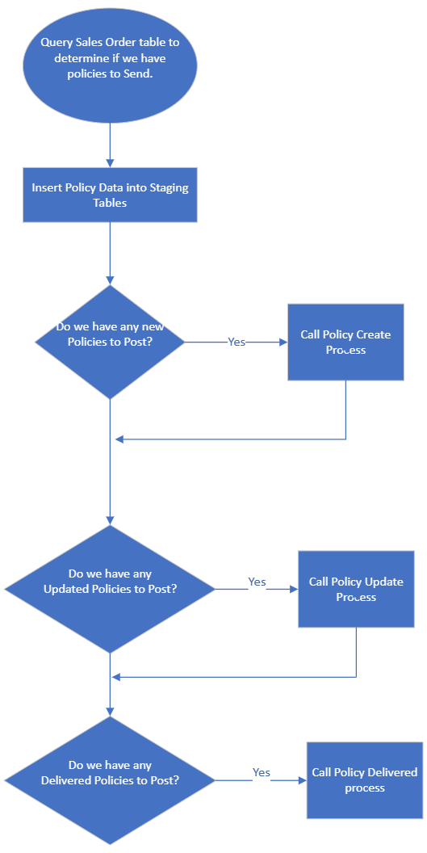

Policy Create Process Flow

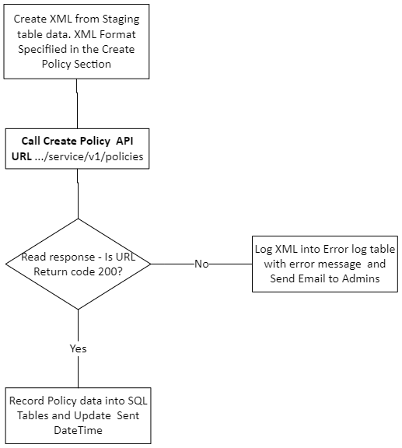

Policy Update Process Flow

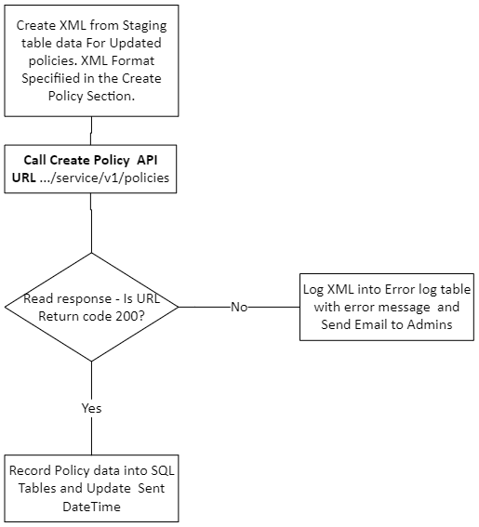

Policy Delivered Process Flow

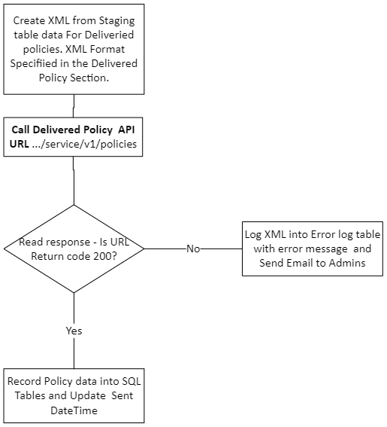

Overview – SQL Server Tables and Stored Procedures

Uniters Schema will be used. All database objects will start with the prefix ‘UNI’.
- Add fields to the existing SaleOrder Plus tables to Indicate the Uniters Policy Tier and Type Purchased.
- Create a set of staging tables – these are defined in the Uniters Group Policy XML Format document.
- Create a stored procedures to populate the staging tables
  - Data must be in coherence with standards set forth with the XML Format document.
  - A email to report on invalid data will be email to DatabaseAdmins.
- Create a set Audit tables to record what was sent.
- Create Error Log Tables.
- Create a Stored Procedures to populate the above tables.

Assumptions/Concerns
- Network Admin will have to white list the API URL.
- We still need additional information on how the United Information will be identities.
- Possible issue with idea of Adding
a field to the ECat data to indicate sold.
- Product Classification -SKU/Service code issue.
- Sending once per day.
- Retail Only.
- Cancelations will be handled as updates.
- APIs calls will be using the Stored Procedures and the process will be run using a SQL Server Job.
- SQL will ISO/Development environment will be available.

Summary of Process
- SQL Job runs once daily.
  - Query Data from SYSPRO/ECat into Staging Tables
    - Post New, Updated or Delivered Policies in XML Format using Staging tables as your basis.
      - Check return code 200 for successful posting XML.
      - Write Sent Data to Logging Tables and update Sent Field.
    - If error on API call, send email and exit

Configuration

Job Scheduler Entries
- Job needs to be created on SQL Server to run daily.
    - Job should be set to retry 3 times before exiting job failure will send email to Admins.

File/Table Definitions

Settings Table
FIELD_NAME | FIELD_DESCRIPTION | KEY | LENGTH | DATA_TYPE
SettingID | PrimaryKey | Y |  | INT
Type | Type of Application | Y | 50 | VARCHAR
Environment | Environment |  | 10 | VARCHAR
Active | Is Active? |  | 1 | BIT
Name | Name |  | 50 | VARCHAR
ApplicationID | ApplicationID |  |  | TinyInt
ApplicationCode | Abbreviation |  | 3 | VARCHAR
SettingDocument | XML Document* |  |  | XML
*The XML document contains the User Logins, passwords, file paths, archives, URLs, and Connection Strings.

Definition and specification of the fields are found in the XML format Document.

ADDITIONAL TABLES WILL BE ADDED WHEN INFORMATION IS PROVIDED.
Brains API containing the required elements definitions are defined in the Brains API Section.
Data examples are listed there as well.

